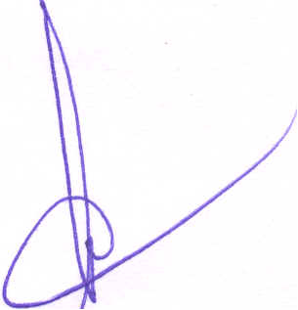

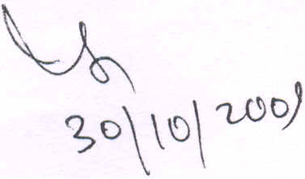

Government of India
Ministry of Communications and IT
Department of Telecommunications (AS-IV Cell)
' 20, Ashoka Road, New Delhi - 110 117

No.842-1070/2009-AS-IV

1. Bharat Sanchar Nigam Ltd. Bharat Sanchar Bhawan, Janpath, New Delhi - 110001.

3. Dishnet Wireless Ltd.
5th Floor, DLF Cyber City, Building No. lOA, Gurgaon - 122 001.

5. Vodafone Essar Spacetel Ltd. C-48, Okhla Industrial Area, Phase- II,
New Delhi - 110020.
7. Idea Cellular Ltd.
1005-6, 10th Floor,
Kailash Building,
26, Kasturba Gandhi Marg, New Delhi - 110001.
9. S Tel Pvt. Ltd.
1 st Floor, Tower-B,
Unitech Cyber park,
Sector-39, Gurgaon - 122001.

11. Tata Teleservices Ltd. 10th Floor, Tower-I, Jeevan Bharati, COlmaught Circus, New Delhi - 110001
Dated: 30th Oct, 2009
2. Bharti Airtel Limited
Unitech W orId Cyber Park, Tower-A, 4th Floor,
Sector 39, Gurgaon - 122001
4. Reliance Communications Ltd. 15th Floor, Vijaya Building,
1 ih Barakhamba Road, Connaught Place,
New Delhi - 110 001.
6. Datacom Solutions Pvt. Ltd.
4th Floor, 248, Plase-IV,
Udyog Vihar,
Gurgaon - 122 015.
8. Loop Telecom Private Ltd. 708-709, Prakash Deep Building, 7, Tolstoy Marg,
Connaught Place,
New Delhi - 110001.
10. Sistema Shyam TeleServices Ltd. 10th Floor, Tower-I,
Jeevan Bharati,
Connaught Circus,
New Delhi - 110001.
12. Unitech Wireless (North) Pvt. Ltd., The Masterpiece, Plot No.1 0, Golf Course Road,
Sector-5'4, DLF Phase-V, Opposite IBIS Hotel,
Gurgaon - 122 001.

Subject:

Suspension of sale of prepaid mobile connection and renewal of
existing prepaid SIM cards .

In exercise of the powers conferred under clauses 10.1 10.6, 30.1 and 41.11 of the Unified Access Service / Cellular Mobile Telecom Service Licence, in the interest of the national security, all licensees of JamIIU:1"'& Kashmir service

Contd.. ./2

: 2:

area, are hereby directed by the Licensor that no prepaid mobile connection shall be issued in Jammu and Kashmir from 0000 hours of 1st Nov, 2009 and existing pre-paid SIMs shall not be renewed for Jammu and Kashmir service area from 0000 hours of 1st Nov, 2009.

~ ~D\\\)\u!(J Y
(Shashi Mohan) I
Director( AS-IV)
Tele: 23372063/ FAX:23372404

Copy to:
1. Secretary, TRAI, New Delhi
2. DDG(S), DoT, New Delhi
3. DDG(AS-I), DoT, New Delhi
4. DDG(TERM), J&K, Jammu
5. Jt. Secretary (IS), MHA, North Block, New Delhi
6. Press Information Bureau, New Delhi
/b~~(( g~J I DCI, NPu.?~\M'; frrr fO~h"'} 6~ 1JOT LvRb'~'vtp.

