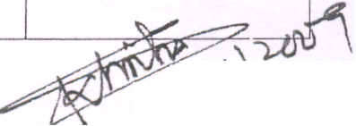

Government of India
Ministry of Communications & I.T.
Department of Telecommunications
Licensing Cell (AS-III Division)
No. 16-5/2009-AS.III/VoI.III8 ~ - 40lh Nov., 2009
Mis. Tata Teleservices Limited
Mis. BSNL
Mis Reliance Communications Ltd.
Sub: Allotment of MSC Codes
In consideration of the request(s) of following service provider(s), the undersigned is directed to convey the approval of the competent authority for allotment of add itional MSC Codes as per detai Is given below:

SI. I Service Provider No.

BSNL

Service Area

Andaman & Nicobar and West Bengal
Haryana
Kolkata Metro city Tamilnadu

Access I MSC Code(s)
Code for full mobility
 | service
89 | 000-009
89 | o 1 0-0 1 9
89 | 020-029
89 | 030-039

2 3

Mis Tata Teleservices Ltd. Mis Reliance Communications Ltd.

Karnataka Gujrat

89 89

040-049 050-059

:\,,\
'2-()
(Sudhir Kumar Sinha) Section Officer(ASIII)

Copy for information and necessary action to:
1 . Secretary, TRA I
2. CMO, BSNL/~
3. Sr.OOG(TEC),OoT
4. DDG(Security), DoT
~ DOG(C&A) for posting to the website ofOoT
6. G.M. (NWO - CFA)/NWO -CM),BSNL
7. Shri D.C. Gupta, GM(OPS), MTNL, Minto Road, New Delhi 8. Director(AS -IVI CS-III)
9. DG COAl
10. SG, AUSPI
II. IB, MHA

